**UNITY INTERNSHIP PROGRAMMER QUEST**

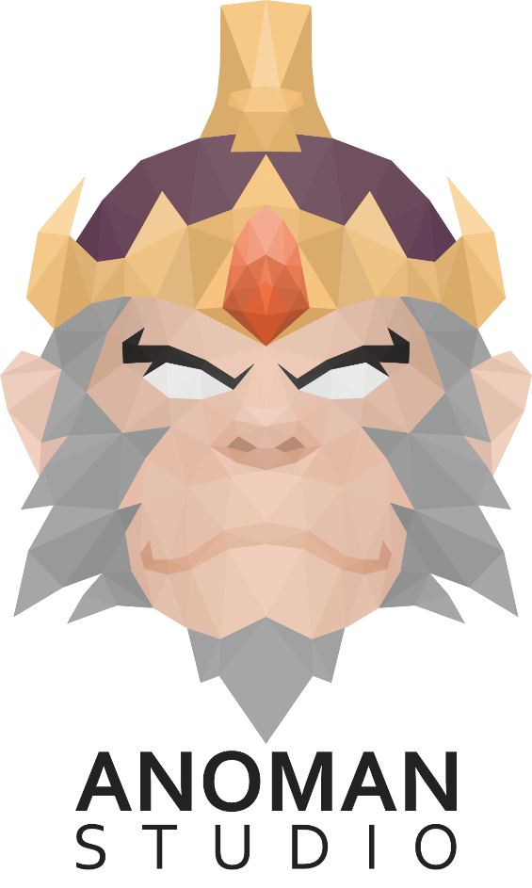

To answer the question, you must use Unity Game Engine with minimum version of 2018.3

And upload your Unity project for the answer on GitHub or Google Drive.

1. **Create UI transitions like from GIF1.**

When the user selects one of the buttons:

A. Then there will be a movement of the indicator (indicator for the selected button), the indicator moves from the position of the previously selected button to the newly selected button

B. There are also several other changes such as the appearance of text, changes in size / position of the UI and others.

The UI layout and contents must be similar. The sprite and icon that is used may also be just an empty sprite as shown in **GIF2**.

UI Reference : “[Archero](https://play.google.com/store/apps/details?id=com.habby.archero&hl=en)” mobile game, from the bottom panel of Main Menu

1. **Create a simple fighting game**

The input must be using tap (input for mobile) and click (input for editor).

The player will use different screen gestures similar to other fight style games.

1. **Create User Controls**

Each screen interaction has an animation attached to the fighter. The screen gestures are listed below with their corresponding animations (See Unity Link for Animations):

1. Tap = Punch

4x animations: First Tap = **Left** **punch**, Second Tap = **Right punch**, Third Tap = **Left** **Hook**, Fourth Tap = **Right** **Hook**. Each time the user touches the screen, their character will play one of these animations in sequence, and will start again from the left punch if the sequence is complete or there is no tap within a certain period of time.

1. Fast Double Tap = **Combo** **Attack**

2x animations: If the user double taps the screen, their fighter will perform 1 of 2 different **combo** **attacks**

1. Swipe Up = **Elbow Attacks**

1x Animations: If the user swipes up on the screen, then the fighter will perform **elbow** **attacks**

1. Two Fingers = **Ready** **Fight** **Idle** (Blocking)

1x Animations: If the player uses two fingers to touch the screen, then the fighter will use the **Ready Fight Idle** animation

If the user did not perform any action, then the character will perform **idle** animation.

1. **Create AI Responses**

The AI will have 20% chance to block every time the user performs an action/input.

While blocking, the AI ​​will perform **Ready** **Fight** **Idle** animation in the short period of time.

The AI will perform 1 of 6 different animations if user performs an action (receive hit animation):

1. **Left hit** animation when user performing **left** **punch**/**hook**
2. **Right** **hit** animation when user performing **right** **punch**/**hook**
3. **Middle** **hit** animation when user performing **elbow** **attacks**
4. **Left** **block** animation when user performing **left** **punch**/**hook** and the AI is blocking
5. **Right** **block** animation when user performing **right** **punch**/**hook** and the AI is blocking
6. **Middle** **block** animation when user performing **elbow** **attacks** and the AI is blocking

Use The Boss model from the animation folder for character in the game.

Feel free to contact us if you have any question.

GOOD LUCK!